E-Calender

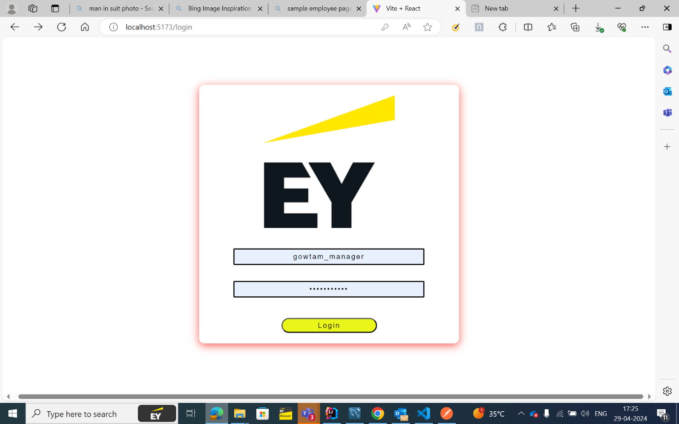Screenshots of the Capstone Project

